PANEL ASSESSMENT BRIEFING REPORT
NORTHERN REGIONAL PLANNING PANEL

PANEL REFERENCE & DA NUMBER | 2014NTH020 – DA 2015/0096
PROPOSAL | - Subdivision of land to create 184 lots including:  - 175 residential lots,  - 3 residue lots,  - 4 public reserves,  - 1 drainage reserve &  - 1 sewer pump station lot,  - Upgrading of Iron Gates Drive, including clearing work in the road reserve,  - Demolition of existing structures, including a dwelling;  - Associated subdivision infrastructure works
ADDRESS | Lot 163 DP 831052 and Lots 276 & 277 in DP 755624 (240 Iron Gates Drive, Evans Head)
APPLICANT | GoldCoral Pty Ltd
OWNER | GoldCoral Pty Ltd
DA LODGEMENT DATE | 27 October 2014
APPLICATION TYPE | Development Application (Integrated) (proposed Concept DA)
REGIONALLY SIGNIFICANT CRITERIA | Coastal Subdivision - Clause 9(b) of Schedule 4A of the EP&A Act (retained as Regionally Significant Development under Clause 8(b) of Schedule 7 to SEPP (State and Regional Development) 2011)
CIV | $11,395,333.00 (excluding GST)
CLAUSE 4.6 REQUESTS | N/A
LIST OF ALL RELEVANT PLANNING CONTROLS (S4.15(1)(A) OF EP&A ACT) | - State Environmental Planning Policy No 71 – Coastal protection;  - State Environmental Planning Policy No. 55 – Remediation of Land;  - State Environmental Planning Policy No 14 – Coastal Wetlands;  - State Environmental Planning Policy (State and Regional Development) 2011;  - State Environmental Planning Policy (Infrastructure) 2007;  - Draft Remediation of Land SEPP;  - Proposed Housing Diversity SEPP;  - Draft SEPP (Environment);  - Richmond Valley Local Environmental Plan 2012
TOTAL & UNIQUE SUBMISSIONS | 565 total submissions in three (3) separate notification periods.
KEY ISSUES | Subdivision design and ecological, bushfire and foreshore issues
DOCUMENTS FOR CONSIDERATION | Proposed amendments to the DA dated 26 July 2021
PREPARED BY | Kim Johnston (Consultant - Regionally Significant Development, DPIE)
DATE OF REPORT | 17 August 2021

Executive Summary

This briefing note has been prepared to provide an outline of the proposal, an update on its progress and to consider whether to accept an amendment to the application proposed by the applicant pursuant to Clause 55 of the Environmental Planning and Assessment Regulation (‘the Regulation’). A brief outline of the site and locality as well as the proposal and background are also provided below.

- THE SITE AND LOCALITY

  - The Site

The subject site comprises three (3) allotments (Lot 163 DP 831052 and Lots 276 & 277 in DP 755624) and is known as 240 Iron Gates Drive, Evans Head (‘the site’). Evans Head is a coastal village with a population of approximately 2,847 with housing largely single detached dwellings with a town centre comprising a variety of shops and commercial services.

Bundjalung National Park is located to the south, Broadwater National Park to the north and the coastline to the east. The Evans Head Memorial Aerodrome exists to the north-west of the site, currently used by limited recreational and general aviation and an aviation museum. The Evans Head Weapons Range is located to the south of the town and is still used.

The site consists of an overall site area of 72.31 hectares and is located approximately 1.5km south west of the Evan Heads town centre. The site has a frontage to the Evans River along its southern boundary as a Crown Foreshore Reserve owned and managed by Crown Lands and the Council (land reserved as a road reserve) and is surrounded on all other boundaries by natural vegetation. The location of the site is illustrated in Figures 1 and 2.

The site is accessed via an existing public road, known as Iron Gates Drive, to the east of the site, which currently comprises a bitumen carriageway of approximately 6 metres in width with no kerb or guttering, an unformed shoulder and no line markings (refer to Figure 3). Natural vegetation adjoins the road on both sides and in parts overhangs the road. Iron Gates Drive links the site with the Evans Head urban area to the north-east. The site conatins areas of remant native vegetation including areas of littoral rainforest, eucalypt forest and coastal wetlands. The site is located within a sensitive coastal location.
Subject site
Figure 1: Site Location (Source: Waiver Request, Planit Consulting Pty Ltd, October 2014)
Figure 2: Aerial view of the site with Evans Head Township in the background
(Source: Planit Consulting Pty Ltd, October 2015)
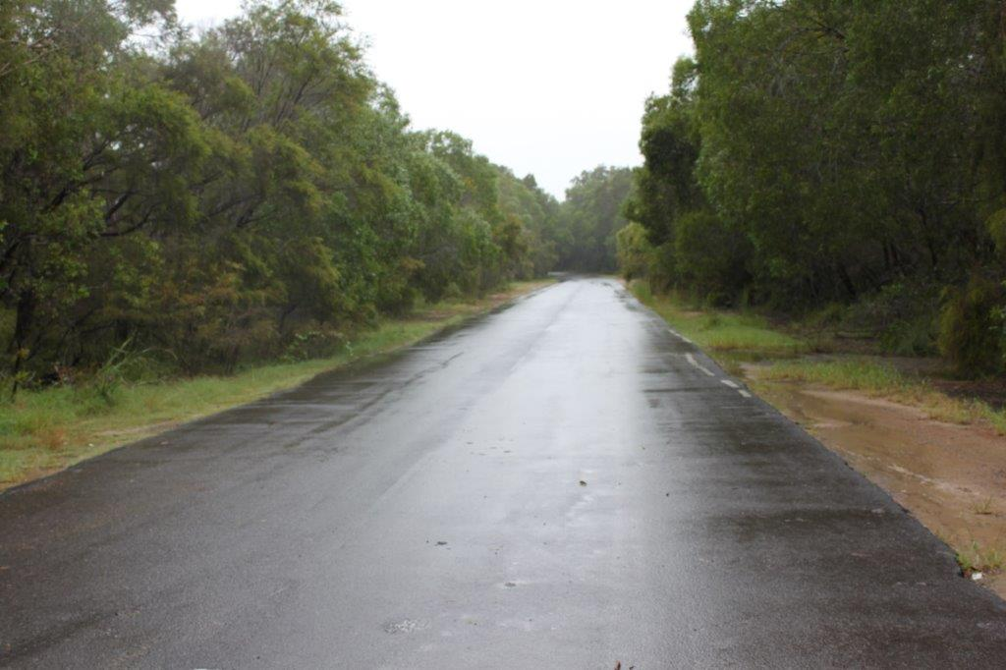
Figure 3: Existing public road access to the site - Iron gates Drive looking east towards Evans Head
The site is generally vacant land with the exception of former subdivision works comprising roads and stormwater infrastructure and bushfire maintenance works having been undertaken on the land. This has resulted in a number of large cleared areas and roads and trails. The remainder of the site contains native vegatation, some of which is remnant vegetation, while other parts are regrowth vegetation following earlier claing works.

The existing roads, mainly in the eastern section of ths site, have signficant cracking of the surface and have been partially washed away in some areas.This existing infrastructure on the site is unlikely to be adequate to be used for future development given this level of disrepair and the likely need for upgrading to meet curent Australian standards and controls (Figures 4 & 5). A single detached dwelling, shed and gravel driveway is located in the south eastern corner of Lot 163. (Figure 6).

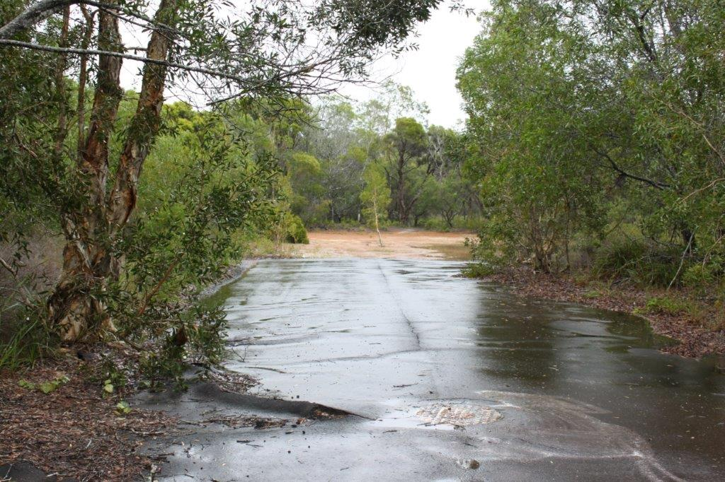
Figure 4: Existing subdivision infrastructure on the site in disrepair

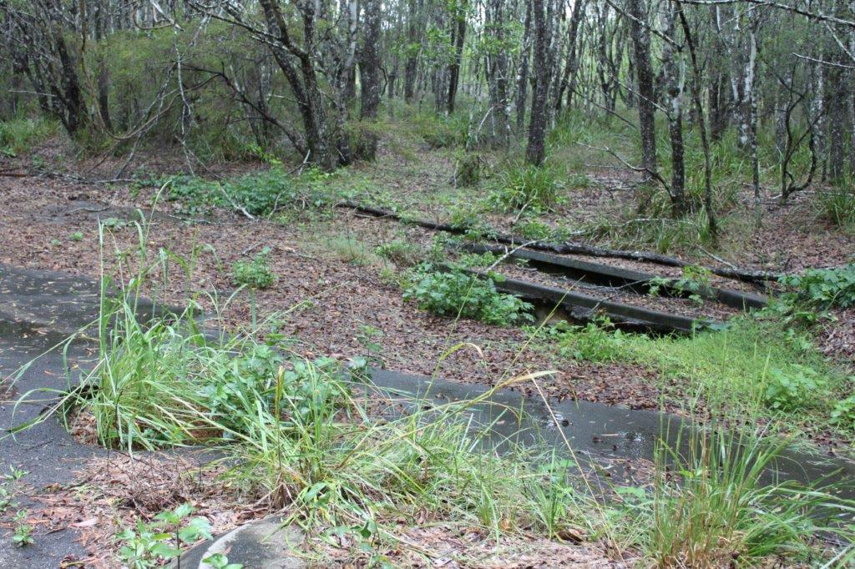
Figure 5: Existing subdivision infrastructure on the site in disrepair

Figure 6: The existing dwelling and shed within Lot 163

- THE PROPOSAL AND BACKGROUND

  - The Proposal

The proposal seeks consent for subdivision of the site and the provision of the associated infrastructure. Specifically, the proposal involves:

- 184 lot subdivision comprising:
- 175 residential lots;
- 4 public reserve lots;
- 3 residue lots;
- 1 drainage reserve lot; and
- 1 sewer pump station lot;

- Upgrading of Iron Gates Drive;

- Demolition of existing dwelling and ancillary structures;

- Subdivision work – including road works, drainage, water supply, sewerage, landscaping and embellishment work and street tree planting

The proposed development is classified as Integrated Development under:

- Section 100B of the Rural Fires Act 1997;
- Section 90 of the National Parks and Wildlife Act 1974; and
- Section 91 of the Water Management Act 2000.

  - Background

The development application was lodged on 27 October 2014 and has been formally amended under Clause 55 of the Regulation on three (3) separate occasions. The application has also been notified on three (3) occasions, receiving a total of 565 submissions, primarily comprising objections to the proposal.
A draft master plan was lodged on 30 October 2015 pursuant to Clause 18(1)(d) of State Environmental Planning Policy 71 – Coastal Protection (‘SEPP 71’). Following consideration of this draft master plan by relevant state agencies and the Department over a number of years, the Government Architect of NSW (‘GANSW’) undertook a design review of the proposal. A number of significant concerns arose from this review and it was acknowledged that such issues remain largely unresolved.

These issues were described by the GANSW as generally attributed to a lack of an integrated urban and landscape design and that cumulatively, the draft master plan did not appear to deliver appropriate urban design outcomes in its current form. Numerous recommendations for improving the urban design and amenity of the precinct were made which covered matters relating to place and context, the overall subdivision plan (including streets, interfaces, access, connection and lot sizes), built form, integration with the natural environment and ongoing place management.

Subsequently, the draft master plan application was formally withdrawn by the applicant on 19 July 2021 and is proposed to be replaced with a Concept DA, as outlined in the proposed amendments pursuant to Clause 55 which are discussed in this report.

A chronology of the development application since lodgement and the draft mater plan (now withdrawn) is outlined in Tables 1 and 2 respectively.

Table 1: Chronology of the DA
Date | Event
27 October 2014 | Lodgement of DA with Council
3 November – 8 December 2014 | Public exhibition (Exhibition #1) - Total 51 submissions – 50 objections and 1 submission of support
18 November 2014 | Request for additional information made by Council (Stop the Clock) outlining 43 matters including engineering, bushfire, foreshore, coastal, public open space and ecological issues.
15 December 2014 | A further request for additional information (Stop the Clock) made by Council & Integrated Agencies.  - RFS dated 9/12/2014  - OEH dated 4/12/2014  - NSW Police (submission dated 27/11/2014  - NSW Local Land Services dated 10/12/2014.
22 December 2014 | A further request for additional information (Stop the Clock) for additional information made by Council & NSW Office of Water letter (dated 15/12/2014)
23 October 2015 | Amendment to the DA (First Amendment) accepted by Council pursuant to Cl 55 of the Regulation, included several changes to configuration of roads and allotments resulting in 183 lot subdivision (including 176 residential lots)
4 November 2015 – 7 December 2015 | Public exhibition (Exhibition #2) for the amended DA - Total 31 submissions – 25 objections and six in support of the development.
10 September 2018 | Addendum submitted (but not accepted by Council) which contained a number of changes to the configuration of roads and allotments, so the DA was consistent with changes to the Draft Master Plan. It also incorporated upgrades to Iron Gates Drive as part of the DA. Council did not accept the addendum and on 7/11/2018 conditions to be met before an amended application could be accepted
17 January 2019 | Amended application lodged (but not accepted by Council)
26 July 2019 & 17 September 2019 | A further amended application was lodged, with several corrections needed to several reports with these being submitted.
18 September 2019 | Crown Land owner’s consent supplied
19 September 2019 | Amendment to the DA (Second Amendment) accepted by Council pursuant to Cl 55 of the Regulation and replaced all previously submitted documentation for-  - Subdivision to create 184 lots comprising – 175 residential lots, 3 residue lots, 4 public reserves, 1 drainage reserve and 1 sewer pump station lot  - Upgrading of Iron Gates Drive  - Demolition of the existing structures on site  - Subdivision work including road works, drainage, water supply, sewerage, landscaping and embellishment work and street planting.
3 October – 18 November 2019 | Public exhibition (Exhibition #3) for Second Amended DA – total number 557 submissions including:  - 202 supporting the development  - 350 objecting to the proposal including one petition with 304 signatures  - Three (3) comments being neutral but of those, two suggesting Council to do thorough assessment and provide good development  - Two (2) submissions providing additional technical information to their objections.
29 July 2020 | Amendment to the DA (Third Amendment) accepted by Council pursuant to Cl 55 of the Regulation to provide  - consistency between DA and draft master plan  - stormwater management plan for works on Iron Gates Drive;  - minor changes to the subdivision layout (which including minor changes to Lots 12 & 13 to provide for a widened Fire Trail); and  - removal of all foreshore embellishments from the foreshore Crown reserve.  This amendment aims to and was not re-exhibited as these are considered to be minor.
26 July 2021 | Further amendment to the DA proposed to comprise a Concept DA pursuant to Section 4.22 of the EP&A Act (not currently accepted).

Table 2: Chronology of the Master Plan
Date | Event
25 October 2014 | Request to waive the requirement for a master plan 9180 lot subdivision) lodged with DPIE pursuant to Cl 18(1)(e) of SEPP 71.
31 March 2015 | NRC did not support waiver application due to the scale and location of the proposal and considered there was insufficient information to address SEPP 71
3 May 2015 | Waiver application declined
30 October 2015 | Lodgement of draft Master plan application for 183 lots (176 residential lots, 4 public reserve lots (including fire trails) and 3 residue lots) lodged by Planit Consulting Pty Ltd (included 8 annexures)
January 2016 | Referrals to government agencies
1 February – 7 March 2016 | Draft master plan exhibited - 31 submissions were received from the public with 13 supported the proposal and 18 were opposed. 10 submissions were received from Government agencies.
26 May 2016 | DPIE request additional/ amended information:  - OEH does not support the master plan in its current form – proposal to be redesigned to avoid direct and indirect impacts on biodiversity and previously identified recommended 50m vegetated buffers to significant environment areas be incorporated into the design and the inclusion of roads in these buffers are not considered acceptable. An offset package is recommended if impacts cannot be avoided (primarily for the DA but would help inform the master plan). Also concerns with the Flora and fauna report.  - RFS) concerns included access to the site and whether it complied with PfBP 2006 (including potential removal of SEPP 14 and other coastal vegetation).
28 June 2016 | Meeting with applicant, Council and agencies
29 May 2018 | Biodiversity offset package finalised with OEH
24 July 2018 | Draft master plan on hold - Applicant advised Draft master plan on hold until RFS access issue resolved.
25 October 2019 | Revised draft master plan lodged prepared by DAC Planning Pty Ltd proposes 184 total lots (175 residential, 3 residue, 4 public reserves, 1 drainage reserve and 1 sewer pump station lots) and upgrading of Iron Gates Drive (included 13 annexures).
6 November – 13 December 2019 | Revised draft master plan exhibited - 88 submissions received (60 in support; 28 objections). Numerous issues raised by agencies that are to be addressed by the applicant in a response to submissions document.
March 2020 | Response to Submissions report lodged by DAC Planning Pty Ltd to address issues raised in submissions. Draft master plan is for 184 lots (175 residential, 4 public reserves, 3 residue, 1 drainage and 1 sewer pump lot) (included 10 annexures) and provided an amended plan of proposed subdivision.
17 September 2020 | Review by the GANSW under the NSW State Design Review Panel Pilot Program, with correspondence dated 19 October 2020 outlining several significant concerns with the proposed draft master plan.
12 November 2020 | DPIE requests further information from the applicant to finalise assessment of the draft master plan following the review by the GANSW.
23 November 2020 | Response from applicant – urban design response provided from RPS on behalf of the applicant to address the issues raised by the GANSW for Stage 1 subdivision.
10 December 2020 | Revised draft master plan lodged by DAC Planning Pty Ltd proposing a reduced subdivision layout to comprise only Stage 1 – 95 residential lots, 4 residue lots, 2 public reserves, 1 drainage reserves and 1 sewer pump station.
19 July 2021 | Draft master plan application withdrawn by the applicant.

- AMENDED PLANS

  - The Amended Plans

The applicant, Goldcoral Pty Ltd, has lodged with the Council a proposal to submit amended plans which will involve the proposal being for a Concept DA pursuant to Section 4.23 (3) of the Environmental Planning and Assessment Act 1979 (‘EP&A Act’) and will be carried out in two stages as described below:

Stage 1

- Completion of all subdivision work for the Stage 1 and future Stage 2 lots, including but not limited to:
- Clearing and earthworks.
- Roadworks and drainage.
- Sewer and water supply (including service connections to the Stage 1 lots and future Stage 2 lots).
- Electricity and communications (including connections to the Stage 1 lots and future Stage 2 lots).

- Embellishment of the proposed public reserves adjacent to the Evans River foreshore.

- Creation of:
- 135 residential lots comprising Lots 1 to 135.
- Creation of 4 public reserve lots comprising Lots 139 to 142.
- Creation of 1 sewer pump station lot comprising Lot 144.
- Creation of 1 drainage reserve lot comprising Lot 143.
- Creation of 3 super lots (comprising Lots 145, 146, 147).
- Creation of a residue lot (Lot 138).
- Creation of 2 Rainforest Lots 137 & 136.

- Upgrading of Iron Gates Drive

Stage 2

Subdivision of super lots 145,146 &147 to create 40 residential lots. No subdivision work is required for Stage 2 as all subdivision infrastructures will be provided with Stage 1.

The amended proposal, if lodged by the applicant and accepted by the Panel, is essentially the same as currently proposed except that the 40 lots in Stage 2 would be subject to a further DA.

  - Accepting the Amendments

Clause 55 of the Regulation sets out the procedure for amending a development application, which states (emphasis added):

- A development application may be amended or varied by the applicant (but only with the agreement of the consent authority) at any time before the application is determined, by lodging the amendment or variation on the NSW planning portal
- If an amendment or variation results in a change to the proposed development, the application to amend or vary the development application must include particulars sufficient to indicate the nature of the changed development.
- If the development application is for—
- development for which concurrence is required, as referred to in section 4.13 of the Act, or
- integrated development,
the consent authority must immediately forward a copy of the amended or varied application to the concurrence authority or approval body.

Importantly, this Clause requires the agreement of the consent authority for an application to be amended in subclause (1). Pursuant to Section 2.15(a) of the EP&A Act, the Panel is the consent authority for regionally significant development and accordingly, it is the Panel’s decision whether or not to accept the amendments for this development application.

The power to amend development applications under Clause 55 has been the subject of numerous cases in the Land and Environment Court of NSW. In Ebsworth v Sutherland Shire Council [2005] NSWLEC 603 (‘Ebsworth’), Talbot J held that an amendment to a development application could not be such as to convert it into a “fresh application”. His Honour at [35] endorsed the following two criteria that could be helpful in considering whether a development application may be amended (emphasis added):

- Whether the development as amended can be regarded as the same development as the one originally proposed in the context of the characterisation of the overall concept and the surrounding circumstances of the development application, and

- Whether there are essential elements that are so altered in the context of a consideration under the Act that they place the development in a different category for the purpose of assessment.

The Department considers the proposed amendments could be within the scope of Clause 55, however, there are several factors which need to be considered in the Panel’s decision whether to accept the amended plans. These factors include the following:

- Age of the development application;
- Whether any additional land is proposed to be included in the application (and whether that includes SEPP 14 land);
- Whether the proposed amendments comprise designated development;
- Whether sufficient information has been provided

These matters are considered below.

Age of the development application

The development application was lodged on 27 October 2014, which equates to 2,486 days or over 6 ½ years. The application has been amended on three (3) occasions to this point, however, the development application has not been capable of determination given a draft master plan had not been adopted. This matter would be resolved by the proposed amendments to the development application as the concept plan DA currently proposed by the applicant fulfils the draft master plan requirement of SEPP 71.

However, it should also be noted that the matters which prevented a determination of the draft master plan, including ecological, bushfire and other general layout concerns, which were highlighted in the GANSW design review of the proposal, remain relevant. It is considered that the Panel would ultimately need to be satisfied as to whether these issues are satisfied in their determination of the proposal in the future.

Additional land

In this case, there is no additional land to be included in the proposed amendments to the development application as the proposed works to Iron Gates Drive (which includes SEPP 14 wetlands) were included in the amendment pursuant to Clause 55 accepted by Council on 19 September 2019. Accordingly, there is no additional land being included in the currently proposed amendments.

Designated development

Whether the proposal is for designated development in this instance is contained in Clause 7 of SEPP 14 (Coastal Wetlands) and is in relation to the proposed road works along Iron Gates Drive. While this SEPP has since been repealed and replaced with the Coastal Management SEPP, SEPP 14 is applicable to the current application as it was lodged prior to its repeal on 3 April 2018.

The relevant sections of Clause 7 of SEPP 14 states:

(1) In respect of land to which this policy applies, a person shall not:
(a) clear that land,
(b) construct a levee on that land,
(c) drain that land, or
(d) fill that land,
except with the consent of the council and the concurrence of the Director.
......

(3) Pursuant to section 29 of the Act, development for which consent is required by subclause (1) is declared to be designated development for the purposes of the Act.
....
(4) In this clause:
clearing, in relation to land, means the destruction or removal in any manner of native plants growing on the land, but does not include:
(a) the destruction or removal of a plant declared to be a noxious weed within the meaning of the Noxious Weeds Act 1993, by means not likely to be significantly detrimental to the native ecosystem, or
(b) the incidental destruction or removal of native plants lying adjacent to any such noxious plants occurring unavoidably during the process of destroying or removing those noxious plants, or
(c) the destruction or removal of native plants, within 3 metres of the boundary between the lands owned or occupied by different persons, for the purpose of erecting or maintaining a dividing fence between those lands, or
(d) the destruction or removal of native plants, within 0.5 metres of the boundary between the lands owned or occupied by different persons, for the purpose of enabling a survey to be carried out along that boundary by a surveyor registered under the Surveyors Act 1929.
native plants means plants indigenous to the State of New South Wales, including trees, shrubs, ferns, vines, herbs and grasses indigenous to the State.

Development is designated if, pursuant to Subclause (3), it involves any of the activities in Subclause (1) which, for the purposes of this application, may include to clear the land ((a)) or to fill that land ((d)) unless is has an exclusion under Subclause (4)(a) to (d). The proposed works do not qualify for any of the exclusions in Subclause (4) and so it will turn on whether the works in the road reserve constitute clearing the land or filling the land.

Subclause 4 states that clearing, in relation to land, means the destruction or removal in any manner of native plants growing on the land. The Bushfire Report prepared by Melanie Jackson dated 8 March 2017, states:

"The DA includes an application to widen Iron Gates Drive to incorporate a sealed carriageway of 8m wide inside a 20m wide road reserve. There are two sections along Iron Gates Drive which cannot be widened due to environmental constraints, involving mapped SEPP 14 wetlands; However overhanging limbs/branches will be trimmed".

The proposed works include trimming of vegetation/trees which overhang Iron Gates Drive within the SEPP 14 wetland. The Department has been provided with advice from Council that “trimming” does not involve the destruction or removal in any manner of native plants growing on the land and that trimming the overhanging vegetation may be “routine maintenance” under the Infrastructure SEPP and if carried out on behalf of the Council and kept to the minimum extent possible to allow safe use of the road a development consent would not be required. The Council appear to consider that the proposal does not involve any works which are designated development.

The Panel would need to be satisfied that the proposal was not designated development for it to accept the proposed amendments under Clause 55.

Sufficient Information

The application is required to have sufficient information pursuant to (emphasis added):

- Clause 50(1) - “A development application must—

- be in the form that is approved by the Planning Secretary and made available on the NSW planning portal, and
- contain all of the information that is specified in the approved form or required by the Act and this Regulation, and
- be accompanied by the information and documents that are specified in Part 1 of Schedule 1 or required by the Act and this Regulation, and
- be lodged on the NSW planning portal”;

The amended application needs to satisfy the requirements for the lodgement of a DA pursuant to Part 1 of Schedule 1 of the Regulation.

- Clause 55(2) – “If an amendment or variation results in a change to the proposed development, the application to amend or vary the development application must include particulars sufficient to indicate the nature of the changed development;

- Section 4.22(1) – “For the purposes of this Act, a concept development application is a development application that sets out concept proposals for the development of a site, and for which detailed proposals for the site or for separate parts of the site are to be the subject of a subsequent development application or applications”; and

- Section 4.22(5) – “The consent authority, when considering under section 4.15 the likely impact of the development the subject of a concept development application, need only consider the likely impact of the concept proposals (and any first stage of development included in the application) and does not need to consider the likely impact of the carrying out of development that may be the subject of subsequent development applications”.

The application is required to include sufficient information for the consent authority to make a thorough assessment of the proposal. The Council and the Panel must be satisfied that there is (or there can be) sufficient information to thoroughly assess the development application.

In relation to the criteria in Ebsworth, the Panel would need to be satisfied that:

- The proposed amendments result in the same development as the one originally proposed in the context of the characterisation of the overall concept and the surrounding circumstances of the development application – that is, the proposal is still for a residential subdivision; and

- The proposed amendments result in the same essential elements such that the proposal remains in the same category for the purpose of assessment.

- Recommendation

The Panel consider this report in the context of their decision whether to accept the proposed amendments to DA 2015/0096 pursuant to Clause 55 of the Regulation.

